
ATSS’s
Institute of Industrial & Computer Management & Research, Nigdi
Academic Year 2024-2025 MCA I
Project Report: JOBHOOK (Job Portal)

CHAPTER 1: INTRODUCTION
JobHook is a modern and user-friendly job portal that connects talented job seekers with top employers across various industries. Whether you're looking to kickstart your career or hire the perfect candidate, JobHook makes the process fast, simple, and effective. Find jobs, post vacancies, and take the next big step with JobHook – where talent meets opportunity.
Existing System and Need for System Existing System:
  - Current job application methods are scattered across multiple platforms, lacking centralized control, customization, and communication features. Existing portals often have:
  - Poor user interface and navigation issues.
  - Lack of real-time resume building and modification.
  - Inadequate profile visibility and matching algorithms.
  - Manual communication and hiring processes.
Limited customization options for both job seekers and employers.

Drawbacks of the Existing System:
- Time-consuming job application process.
- Difficulty tracking multiple applications.
- Inconsistent communication between employer and candidate.
- Lack of smart matching features based on profile skills.
- Employers struggle to filter and find ideal candidates efficiently.

Needs of the Proposed System:
- Simplify the job application and hiring process.
- Provide a unified platform for both applicants and recruiters.
- Ensure security, privacy, and user data protection.

CHAPTER 2: PROPOSED SYSTEM
Proposed System – JOBHOOK:
JOBHOOK is an integrated job portal platform designed for both job seekers and employers. It includes profile creation, resume builder, job posting, resume screening, application tracking, and candidate hiring. The system emphasizes:
- An intelligent matching system.
- A user-friendly and responsive design.
- Real-time resume creation and editing.
- Secure communication between users.
- Employer dashboards for job and applicant management.
Needs of the Proposed System:
- Simplify the job application and hiring process.
- Provide a unified platform for both applicants and recruiters.
- Ensure security, privacy, and user data protection.
Key features
1 User Registration and Login
- Separate accounts for job seekers and employers
- Secure login with email/password or social login options
2 Job Posting and Management
- Employers can post job vacancies, edit or delete listings
- Option to add job details like title, description, location, salary, and required qualifications
3 Job Search and Filters
- Job seekers can search for jobs by keywords, location, category, company, or salary range
- Advanced filters to narrow down search results
4 Resume Upload and Profile Creation
- Job seekers can upload resumes, fill out professional profiles
- Profile includes skills, experience, education, and preferences
5 Application Tracking
- Job seekers can apply for jobs and track their application status
- Employers can view applicants, shortlist candidates, and manage applications

.

CHAPTER 3: ANALYSIS & DESIGN
3.1 Activity Diagram Employer perspective:

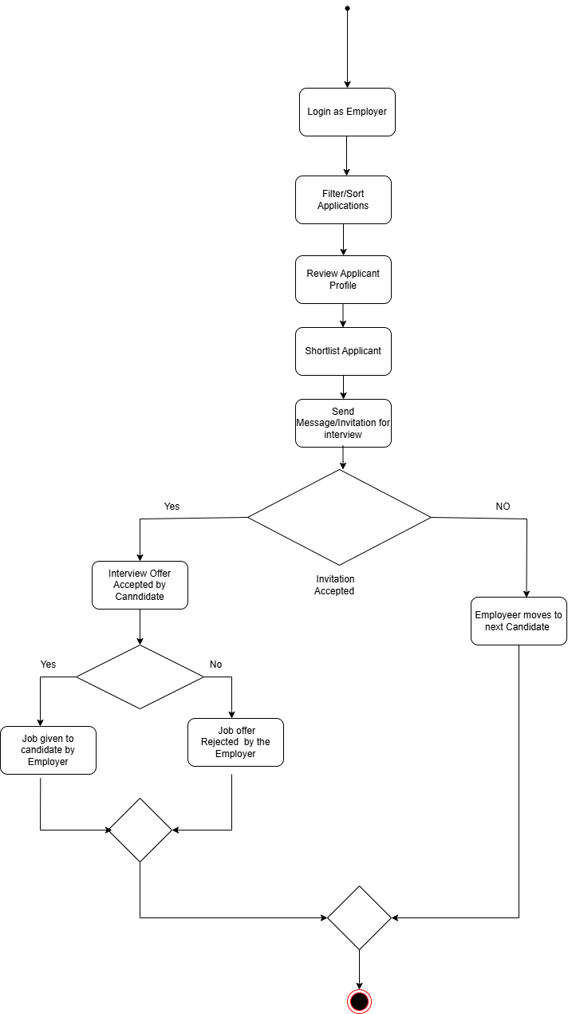

3.2 Activity diagram employee perspective:
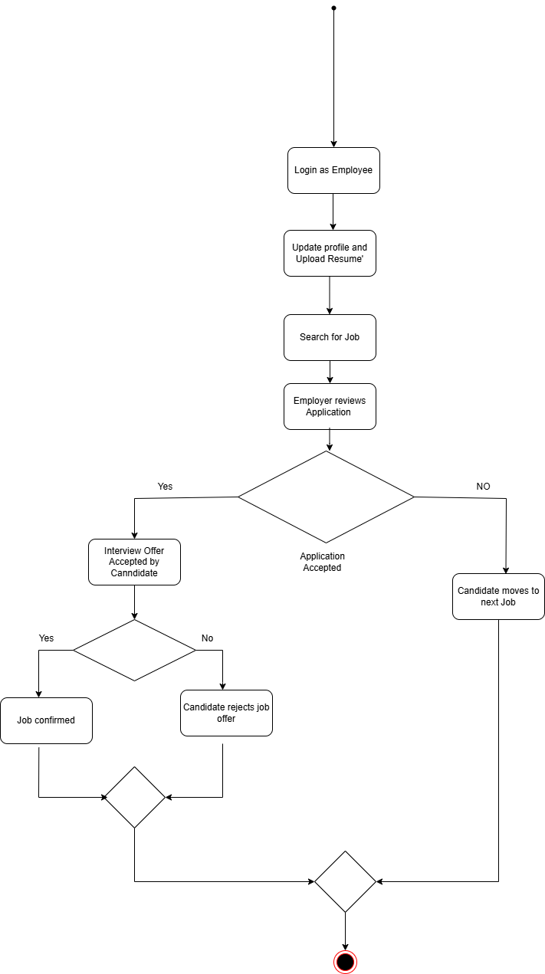
3.3 Deployment Diagram :
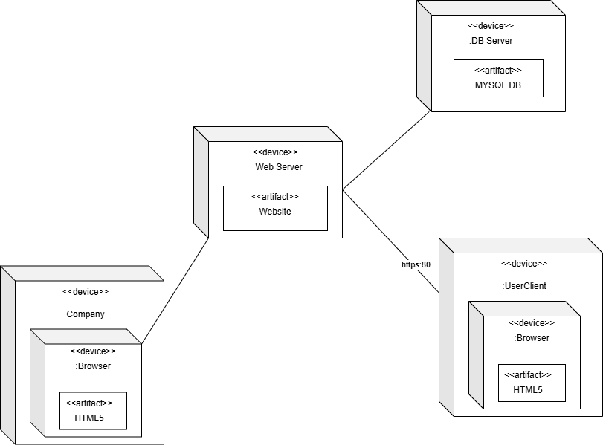

3.5) Sequence Diagram
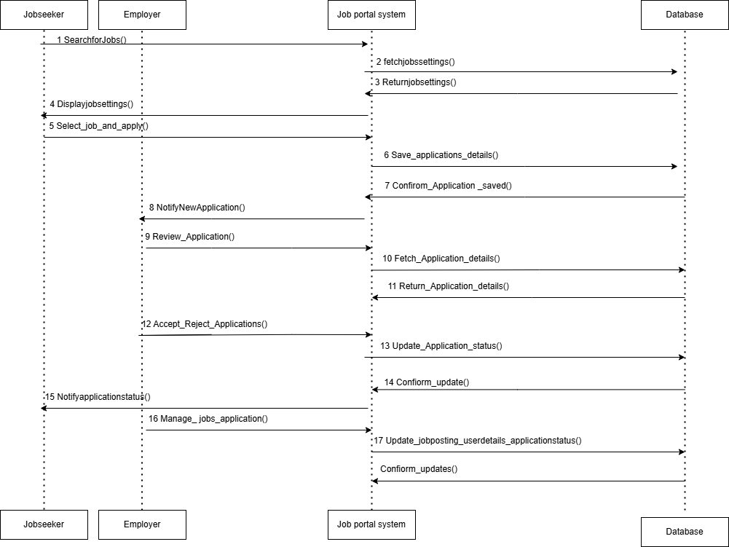

3.6) Class Diagram
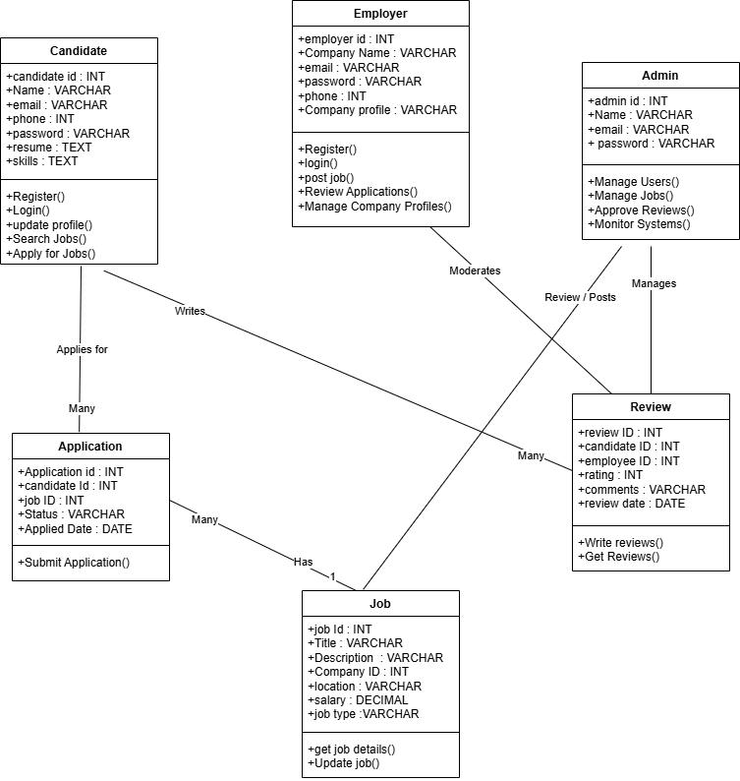

3.7) Use case diagram
